Annual Quality Assurance Report
(1st May. 2017 – 30th April. 2018)

Submitted by
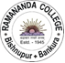

Internal Quality Assurance Cell
Ramananda College,
Bishnupur, Bankura
West Bengal

Submitted to
National Assessment
And
Accreditation Council (NAAC)
Bangalore

Contents

1. Details of the Institution .................................................................................................... 2-5
2. IQAC Composition and Activities .................................................................................... 5-9
CRITERION – I ................................................................................................................... 10-11
1. Curricular Aspects
CRITERION – II .................................................................................................................. 11-13
2. Teaching, Learning and Evaluation
CRITERION – III ................................................................................................................ 14-18
3. Research, Consultancy and Extension
CRITERION – IV ................................................................................................................ 19-20
4. Infrastructure and Learning Resources
CRITERION – V .................................................................................................................. 21-23
5. Student Support and Progression
CRITERION – VI ................................................................................................................ 24-28
6. Governance, Leadership and Management
CRITERION – VII ............................................................................................................... 29- 31
7. Innovations and Best Practices
8. Plans of the Institution for next year.
Annexure 1 ............................................................................................................................ 32-33
Annexure 2 ............................................................................................................................ 34-35
Annexure 3 ............................................................................................................................ 36
Annexure 4 ............................................................................................................................ 37
Annexure 5 ............................................................................................................................ 38-41
Annexure 6 ............................................................................................................................ 42
Annexure 7 ............................................................................................................................ 43

Tel - (03244)252059
Tele Fax – (03244) 254427
e-mail –principal@ramanandacollege.org.in
Website-www.ramanandacollege.org.in

BISHNUPUR * BANKURA
Pin – 722122, West Bengal
UGC Recognized & State Government Aided Constituent College
Under the Bankura University
(Accredited by NAAC at ‘B’ Level)

The Annual Quality Assurance Report (AQAR) of the IQAC
Period : 1st May. 2017 – 30th April. 2018

Part – A
1. Details of the Institution
RAMANANDA COLLEGE
1.1 Name of the Institution
At & PO - BISHNUPUR
1.2 Address Line 1
Dist- BANKURA
Address Line 2
BISHNUPUR
City/Town
WEST BENGAL
State
722 122
Pin Code
principalramananda@gmail.com

Institution e-mail address
03244 - 252059, 254427
Contact Nos.

Name of the Head of the Institution:
Dr. Swapna Ghorai
03244 - 252059 , 254427
Tel. No. with STD Code:
+919434509415
Mobile:

Name of the IQAC Co-ordinator:
Dr. Narendra Ranjan Malas
+919434144468

Mobile:
iqacramananda@gmail.com
IQAC e-mail address:

1.3 NAAC Track ID (For ex. MHCOGN 18879): EC/41/97
http://www.ramanandacollege.org
1.4 Website address:
http://www.ramanandacollege.org/downloads/aqar_2017-18.doc
Web-link of the AQAR:
For ex. http://www.ladykeanecollege.edu.in/AQAR2012-13.doc
1.5 Accreditation Details
Sl. No. | Cycle | Grade | CGPA | Year of Accreditation | Validity Period
1 | 1st Cycle | B++ | NA* | 2007 | 05 Years
2 | 2nd Cycle | B | 2.75** | 2015 | 05 Years
3 | 3rd Cycle
4 | 4th Cycle
- * 83.15 out of hundred **CGPA on four point scale
03.03.2007
1.6 Date of Establishment of IQAC: DD/MM/YYYY

2017-18
1.7 AQAR for the year (for example 2010-11)

1.8 Details of the previous year’s AQAR submitted to NAAC after the latest Assessment and Accreditation by NAAC ((for example AQAR 2010-11submitted to NAAC on 12-10-2011)
- AQAR 2015-16 submitted to NAAC on - 11-05-2016

- AQAR 2016-17 submitted to NAAC on - 23-08-2017

1.9 Institutional Status
-

-
-
-
University State Central Deemed Private


Affiliated College Yes No


Constituent College Yes No



Autonomous college of UGC Yes No



Regulatory Agency approved Institution Yes No
(eg. AICTE, BCI, MCI, PCI, NCI)


Type of Institution Co-education Men Women



Urban Rural Tribal







Financial Status Grant-in-aid UGC 2(f) UGC 12B

Grant-in-aid + Self Financing Totally Self-financing


1.10 Type of Faculty/Programme







Arts Science Commerce Law PEI (Phys Edu)

TEI (Edu) Engineering Health Science Management

PG Programme in Bengali, Botany, English, Mathematics and Sanskrit
Others (Specify)

1.11 Name of the Affiliating University (for the Colleges)
The University of Burdwan (Up to 31-12-2016) and Bankura University (from 01-01-2017 onwards)

1.12 Special status conferred by Central/ State Government-- UGC/CSIR/DST/DBT/ICMR etc
--
Autonomy by State/Central Govt. / University
--
--
University with Potential for Excellence UGC-CPE
--
--
DST Star Scheme UGC-CE
--
--
UGC-Special Assistance Programme DST-FIST
--
--
UGC-Innovative PG programmes Any other (Specify)
--
UGC-COP Programmes
2. IQAC Composition and Activities
2+8
2.1 No. of Teachers
1
2.2 No. of Administrative/Technical staff
-
2.3 No. of students
2.4 No. of Management representatives
2
1
2.5 No. of Alumni
2. 6 No. of any other stakeholder and
1
community representatives
1
2.7 No. of Employers/ Industrialists
--
2.8 No. of other External Experts
16
2.9 Total No. of members
04
]’
loiouyr
2.10 No. of IQAC meetings held

2.11 No. of meetings with various stakeholders: No. Faculty
02
04

0
01
01 (Parents)
Non-Teaching Staff Students Alumni Others



2.12 Has IQAC received any funding from UGC during the year? Yes No

If yes, mention the amount
NA

2.13 Seminars and Conferences (only quality related)* See Annexure - I
(i) No. of Seminars/Conferences/ Workshops/Symposia organized by the IQAC
03
--

03
Total Nos. International National State Institution Level

- Institutional Level Workshop on Promotion of Research Climate in the Institution on 08-03-2018
- Workshop on Modalities of CBCS Introduced at the UG Level by Bankura University
- Workshop on N-List Orientation programme on 07-07-2017
(ii) Themes

2.14 Significant Activities and contributions made by IQAC
Introduction of New Programmes (P.G Programme) | P.G. Programmes in Bengali, English, Mathematics, Sanskrit have been newly introduced from 2017-18 session.
Publications(Initiated by IQAC) | - Journal titled Frontiers in Mutidisciplinary Research  - Book Titled Ramananda Chattopadhyay: JanmaSardhaShatabarsikite Fire Dekha
Academic and Financial Audit | Academic and Financial Audits have been completed in due time
Extension Activities (Supported by IQAC) | NSS Unit: Campus Cleaning, Dengue & Chikungunya Awareness Camp, Celebration of Worlds AIDS Day, Celebration of International Mother Language Day,Annual Camp  NCC: NCC Day Celebration, organized CATC  Women’s Cell: Organized series of seminars on relevant topics including women empowerment and gender sensitization  Blood Donation Camp organized by the Students’ Union.
Staff Training (Initiated by IQAC) | N-LIST Orientation Programme, e-Pension, Software in RS-GIS and Online Admission Sensitization Training, Refresher Course, Orientation Programme, Short – Term Course.
Parent- Teacher Meeting (organized by IQAC) | Parent- Teacher Association(2017-2018) was formed in a meeting with Parents on 10.01.2018
Website Upgradation | Initiative has been taken to keep the website up-to-date.
Promotion of Teachers | IQAC scrutinizes and forwards applications of teachers for promotion.
Research Assistance | IQAC encourages and assists in promoting research climate in the college, such as organizing workshops, making online database accessible, proposal to the Governing Body for contributing fund for research work by the faculty and students of the college, conducting regular meetings of the Research and Seminar committees, encouraging departments to organise seminars, workshops at different levels.
Infrastructure development | Construction of new smart classrooms and theoretical classrooms, upgradation of laboratories, automation in library and office, purchase of new books and subscription of journals, enhancement of sports infrastructure and equipments, upgradation of conventional classroom to virtual classroom.
Foreign Visits | Dr. Swapna Ghorai has presented a paper in 7th IIMS International Conference in Shih Chien University, Taiwan
ICT | ICT /Technology –enabled classes are made compulsory in all Humanities, Social Studies and Science Departments. Already eight Smart Classrooms and one Virtual Classroom are ready for the above purpose
Add on/Job Oriented Programmes | Following the resolution of IQAC proposal for Add on/Job Oriented Programmes has been submitted and four such programmes have got approval of the Bankura University
Proposal for new programmes | Proposal for introducing Honours Courses in Computer Science and Music has been submitted to the Bankura University
Career Advancement Centre (CAC) | Career Advancement Centre is actively organizing Career –Talk, Career Counselling, Seminars, Coaching Classes. Presently CAC functions as a placement Cell to extend job opportunity to outgoing students.

2.15 Plan of Action by IQAC/Outcome
The plan of action chalked out by the IQAC in the beginning of the year towards quality
enhancement and the outcome achieved by the end of the year * See Annexure-II

Plan of Action | Achievements
1. Proposals have been submitted to introduce P.G. programmes in Bengali, English, Mathematics, Sanskrit and Chemistry.  2. To improve teaching-learning process audio-visual facilities will be provided in the large class rooms.  3.To improve research activity among the faculty members Research Committee will encourage the faculty members to apply for research projects, FDP, to present papers in seminars, workshops, conferences.  4. Strengthening and extending the reach of the Career Advancement Centre for career guidance, organizing coaching classes and so on.  5.Initiative will be taken to develop Sports Infrastructure in the college.  6.A number of teaching posts are vacant. The college will send requisition to the competent authority for the recruitment of full-time teachers.  7. Appropriate measures will be taken to ensure students’ attendance in the theoretical and practical classes. Dropout rate of students has to be reduced by providing remedial classes, teacher-student interaction, continuous evaluation of students’ performances.  8. Library facilities will be enhanced and N-list resources will be made accessible to the stakeholders.  .  9.To develop Infrastructure facilities more Classrooms will be constructed, Generator Service will be provided to all parts of the college, all departments will have internet connections, more furniture, fans ,lights will be purchased , Laboratories will be well equipped, renovation work of canteen and toilets will be undertaken, Students will be provided with more sports and games facilities.  10. The college will be maintained as a pollution free ,ragging free, sexual harassment free secured zone. | 1. P.G. programmes in Bengali, English, Mathematics, Sanskrit have been newly introduced from 2017-18 session.  2. One Virtual Classroom with audio-visual facilities has been introduced. Three newly constructed Smart Rooms are prepared for ICT classes. Five theoretical classrooms have been upgraded as Smart Rooms and are now Technology Enabled.  3. Research Committee has conducted meetings at regular intervals and encouraged teachers to undertake research activities at different levels --  - Teachers have published 36 papers  - Teachers have presented 37 papers in International, National, State Level seminars, workshops, conferences.  - 11 teachers served as chairpersons/experts in various academic fields.  4. Career Advancement Centre has conducted Career Talks, Seminars, Workshops. It has also prepared a database of outgoing students.  5.Some measures have been taken to develop Sports Infrastructure in the college. A proposal for purchasing sports equipments from RUSA fund has been submitted.  6.The college has sent requisition to the College Service Commission, West Bengal and as a result 02 full-time faculty members have been recruited. Since the college cannot recruit full-time permanent faculty on its own, adequate number of guest teachers with requisite qualification have been engaged for the academic interest of the students.  7. Introduction of ICT based classes, remedial classes, and such other measures has remarkably improved students attendance in class rooms. Introduction of Internal Assessment, CBCS system will be effective in reducing dropout rate.  8.Steps have been taken to make the library more resourceful and user friendly. N-list resources have already been made accessible to the stakeholders. Facilities for OPAC (Online Public Access Catalogue) are also available to all users in the library. In addition to that 737 books have been purchased during the period.  9.One new classroom has been constructed. Construction works of three Smart Rooms, one Language Lab and a new Computer Centre are almost complete. All sections of the college avail the power back up facility, Office, Library, academic departments have internet facilities. Renovation work will be done with RUSA grant. Sports equipments will be purchased from next instalment of the RUSA grant.  10. Women Cell, Prevention of Sexual Harassment Cell, Anti –Ragging Cell, Grievance Redressal Cell, Eco Club are active to keep the college pollution free, ragging free and sexual harassment free. Women Cell has organized three programmes including women empowerment and gender sensitization, NSS Unit undertook anti-tobacco campaign, campus cleaning, dengue and chikungunya awareness camp. The entire college campus is brought under CCTV surveillance.
* The Academic Calendar of the year as - Annexure-II attached.



2.16 Whether the AQAR was placed in statutory body* Yes No
Governing Body
-
-
Management Syndicate Any other body
*See Annexure III
Provide the details of the action taken
The Governing Body discussed elaborately The Annual Quality Assurance Report, prepared by Internal Quality Assurance Cell of the college. The Report was placed in the meeting of the Governing Body on 26.06.2018.The Governing Body has approved the Report and instructed to submit the same to National Assessment & Accreditation Council (NAAC), Bangalore. The apex body has assured to provide all necessary supports and arrange fund to implement the resolutions and future plans as proposed in the AQAR.

Part – B
Criterion – I
1. Curricular Aspects
1.1 Details about Academic Programmes*
Level of the Programme | Number of existing Programmes | Number of programmes added during the year | Number of self-financing programmes | Number of value added / Career Oriented programmes
PhD | - | - | - | -
PG | 01 | 04 | 05 | -
UG | 22 | - | 01 (Philosophy) | -
PG Diploma | - | - | - | -
Advanced Diploma | - | - | - | -
Diploma | - | - | - | -
Certificate | 01 (Spoken English) | - | 01 | -
Others |  | 01 (Spoken Sanskrit) | - | -
Total | 24 | 05 | 07

Interdisciplinary | - | ** | - | -
Innovative | - | - | - | -
* See Annexure - IV

** Seminar/Exchange Programme with interdepartmental participation for exchange of ideas aided with paper presentations, display of models, charts for motivating students were conducted.

1.2 (i) Flexibility of the Curriculum: CBCS /Core/Elective option/ Open options
(ii) Pattern of programmes:
Pattern | Number of programmes
Semester | 05 PG + 22 UG ( Bankura University)
Trimester | 0
Annual | 20 (UG Part – II, Part – III under Burdwan University)

1.3 Feedback from stakeholders* Alumni Parents Employers Students
-


-


(On all aspects)
Mode of feedback : Online Manual Co-operating schools (for PEI)



*Please provide an analysis of the feedback in the (Annexure - V)

1.4 Whether there is any revision/update of regulation or syllabi, if yes, mention their salient aspects.
The syllabi are updated by The University of Burdwan periodically and CBCS system of Bankura University has been introduced from the academic session 2017-18.

1.5 Any new Department/Centre introduced during the year. If yes, give details.
Yes*

* Four new Post Graduate departments in Mathematics, Bengali, English, Sanskrit (Under the Bankura University) have been introduced.

Criterion – II
2. Teaching, Learning and Evaluation

2.1 Total No. of permanent faculty
Total | Asst. Professors | Associate Professors | Professors | Others
58 | 36 | 19 | -- | 03*

* Principal – 01 and Librarian - 02
37
2.2 No. of permanent faculty with Ph.D.
2.3 No. of Faculty Positions Recruited (R) and Vacant (V) during the year
Asst. Professors |  | Associate Professors |  | Professors |  | Others |  | Total
R | V | R | V | R | V | R | V | R | V
2 | 1 | NA | NA | NA | NA | - | - | 2 | 1
24
05
21 (PTT)
2.4 No. of Guest and Visiting faculty and Temporary faculty

2.5 Faculty participation in conferences and symposia:

No. of Faculty | International level | National level | State level
Attended Seminars/ Workshops | 11 | 28 | 09
Presented papers | 07 | 22 | 09
Resource Persons | 00 | 00 | 00

2.6 Innovative processes adopted by the institution in Teaching and Learning:
- Smart class rooms with audio-visual facilities
- Student seminars, exhibition, presentation
- Model / chart preparation
- Project work (Both U.G. & P.G.) / Field Survey / Excursion

182 days
2.7 Total No. of actual teaching days during this academic year
- Class Tests organised by Depts
- Annual Test Exams. organised by College
- Mock Practical Test organised by Departments.
- Internal Assessment organized by the college
- Spot Assessment conducted by the University with College teachers for speedy & timely publication of results.

2.8 Examination/ Evaluation Reforms initiated by the Institution
(for example: Open Book Examination, Bar Coding, Double Valuation,
Photocopy, Online Multiple Choice Questions)

2.9 No. of faculty members involved in curriculum
-
-
11*
restructuring / revision/ syllabus development
as member of Board of Study/Faculty/Curriculum Development workshop

*Teachers of the college serve as members/conveners of PGBS, UGBS, Syllabus Committee, etc.
75%
2.10 Average percentage of attendance of students

2.11 Course/Programme wise
distribution of pass percentage :
Title of the Programme | Total no. of students appeared | Division
Title of the Programme | Total no. of students appeared | Distinction % | I % | II % | III % | Pass %
B. Sc. (Hons.) | 107 |  | 23.36 | 28.03 | - | 51.40
B. A. (Hons.) | 193 |  | 2.60 | 63.21 | - | 66.83
B. Com. (Hons.) | 04 |  | 0.00 | 50.00 | - | 50.00
B.A. (Gen.) | 1461 |  | - | - | 12.52 | 12.52
B. Sc. (Gen.) | 98 |  | - | - | 45.91 | 45.91
B. Com. (Gen.) | 04 |  | - | - | 25.00 | 25.00
M.Sc. (Botany) | 09 |  | 100 | - | - | 100

2.12 How does IQAC Contribute/Monitor/Evaluate the Teaching & Learning processes:
i. Collects & analyses students’ & parents’ feedback.
ii. Conducts meeting of Parent-Teachers Association.
iii. Promotes result analysis by the academic departments.
iv. Enhances & encourages ICT enabled classes in all departments.
v. Monitoring and evaluation of teaching learning process has also been done with the help of Academic Audit Report.

2.13 Initiatives undertaken towards faculty development

Faculty / Staff Development Programmes | Number of faculty benefitted
Refresher courses | 05
UGC – Faculty Improvement Programme
HRD programmes
Orientation programmes | 02
Faculty exchange programme
Staff training conducted by the university
Staff training conducted by other institutions | 02
Summer / Winter schools, Workshops, etc.
Others (Short term course) | 01

2.14 Details of Administrative and Technical staff

Category | Number of Permanent  Employees | Number of Vacant  Positions | Number of permanent positions filled during the Year | Number of positions filled temporarily
Administrative Staff | 11 | 11 | 0 | 10
Technical Staff | 06 | 12 | 0 | 14

Criterion – III
3. Research, Consultancy and Extension
3.1 Initiatives of the IQAC in Sensitizing/Promoting Research Climate in the institution
- The IQAC encourages teachers to undertake Major and Minor projects funded by UGC/ DST/ CSIR, and other funding agencies. Altogether 03 (three) UGC sponsored Minor Research Projects are being continued during this year. In addition to that, 01 (one) Major Research Project in collaboration with the department of Biotechnology, The University of Burdwan, under the sponsorship of Department of Higher Education, Science & Technology and Biotechnology, Government of West Bengal, has been sanctioned in this session.

- The IQAC motivates the departments to conduct seminar/special lectures to develop research activities. A National level seminar entitled “Recent approaches of Mathematical Sciences in advancement of Biotechnology” was jointly organized by the department of Mathematics and the department of Botany under the sponsorship of Department of Higher Education, Science & Technology and Biotechnology, Government of West Bengal, on March 28, 2018.

- The IQAC extends full cooperation to different departments in organizing seminars or conferences. College level student seminars, for both UG and PG level, have been organized by each of the department of this college during the session 2017-18.

- Teachers are inspired to pursue research work in doctoral and post-doctoral levels. A good number of teachers are engaged in research work. They publish their research papers regularly. Teachers also attend and present papers in national and international seminars/ conferences/ workshops, etc. A number of teachers are involved with various Journals as reviewers, editors and members of editorial boards.

- The Research Sub-Committee and the IQAC work in synchronization to look after the overall research climate in this institution. An institutional level workshop entitled “Promotion of Research Climate in the Institution” was organized by IQAC in association with the Research Sub-Committee on March 8, 2018.

- Frontiers in Multidisciplinary Research, the official research journal of Ramananda College, Bishnupur, Bankura, has been introduce in December, 2017. It is a multi-disciplinary peer-reviewed biannual journal, aimed to promote research publications and to spread the knowledge congregated by the academicians in diversified fields of Natural and Social Sciences, Language and Literature, Fine Arts as well as Business and Management. The IQAC assists the Editorial Board in this connection.

- In response to the suggestion from IQAC, the Governing body of the college has decided to provide Rs. 1 lakh for promoting research within the college by the students and teachers.

3.2 Details regarding major projects
 | Completed | Ongoing | Sanctioned | Submitted
Number | 00 | 01 (Co-PI) | 01 | 01
Outlay in Rs. Lakhs |  |  | Rs. 14.99,240/- | Rs. 16.00000

3.3 Details regarding minor projects
 | Completed | Ongoing | Sanctioned | Submitted
Number | 00 | 03 | 03 | 03
Outlay in Rs. Lakhs |  |  | Rs. 7.95000 | Rs. 11.00000

3.4 Details on research publications
 | International | National | Others
Peer Review Journals | 29 | 07 | 00
Non-Peer Review Journals | - | - | -
e-Journals | 01 | - | -
Conference proceedings | - | 04 | -

3.5 Details on Impact factor of publications:
0 - 2.5
-
-
-
Range Average h-index Nos. in SCOPUS

3.6 Research funds sanctioned and received from various funding agencies, industry and other organisations
Nature of the Project | Duration  Year | Name of the  funding Agency | Total grant  sanctioned | Received
Major projects | 2018-21 | Department of Higher Edn, S & T and Biotech, Govt. of West Bengal | Rs.14.99240/- | Rs.7.66840/-
Minor Projects | 2017-19 | UGC, ERO | 7,95.000/- | 6,50,000/-
Interdisciplinary Projects
Industry sponsored
Projects sponsored by the University/ College
Students research projects
(other than compulsory by the University)
Any other(Specify)
Total |  |  | Rs.22,94,240/- | Rs.14,16,840/-

3.7 No. of books published i) With ISBN No. Chapters in Edited Books
01
08
00
ii) Without ISBN No.
3.8 No. of University Departments receiving funds from
NA
NA
NA
UGC-SAP CAS DST-FIST
NA
NA
DPE DBT Scheme/funds
3.9 For colleges Autonomy CPE DBT Star Scheme
-
-
-
20 Lakhs
(State Govt.)
-
2.4 Lakhs
INSPIRE CE Any Other (specify)
Nil
3.10 Revenue generated through consultancy

3.11 No. of conferences organized by the Institution *
Level | International | National | State | University | College
Number | - | 01 | - | - | 10
Sponsoring agencies | - | DST, WB | - | - | College, Tobacco Control Cell, Govt. of W.B.
*see Annexure - I

*See Annexure-I
3.12 No. of faculty served as experts, chairpersons or resource persons
11
-
04
-
3.13 No. of collaborations International National Any other
02
3.14 No. of linkages created during this year

3.15 Total budget for research for current year in lakhs:
6,50,000/-
00
From funding agency From Management of University/College
Total
6,50,000/-

Type of Patent |  | Number
National | Applied | -
National | Granted | -
International | Applied | -
International | Granted | -
Commercialised | Applied | -
Commercialised | Granted | -
3.16 No. of patents received this year

3.17 No. of research awards/ recognitions received by faculty and research fellows
Of the institute in the year
Total | International | National | State | University | Dist | College
12 | 04 | 02 | 06 | -- | - | -

05
3.18 No. of faculty from the Institution
Who are Ph. D. Guides

and students registered under them
02

3.19 No. of Ph.D. awarded by faculty from the Institution
-

3.20 No. of Research scholars receiving the Fellowships (Newly enrolled + existing ones)
-
-
JRF SRF Project Fellows Any other
-
-

3.21 No. of students Participated in NSS events:
200
-
University level State level
-
-
National level International level

3.22 No. of students participated in NCC events:
140
05
University level State level
01
00
National level International level

3.23 No. of Awards won in NSS:
-
-
University level State level
-
-
National level International level

3.24 No. of Awards won in NCC:
0
0
University level State level
0
00
National level International level

3.25 No. of Extension activities organized
01
03
University forum College forum
-
09
03
NCC NSS Any other
3.26 Major Activities during the year in the sphere of extension activities and Institutional Social Responsibility
- Celebration of 150th Birth Anniversary of Sister Nivedita involving students from different schools & colleges of the locality.
- A seminar organized by the college on World Population Day – 11.07.2017 by NSS unit.
- A Seminar, “Women Empowerment and Gender Sensitization” organized by the Women Cell.
- A camp on health check-up which includes blood test, ECG, road repair in a local slum area
at Bishnupur was organised.
- Dept. Of Bengali has organized a rally for the awareness of modern Bengali spelling among the common people of the locality.
- NSS unit organised campus cleaning, Dengue, Chikungunya awareness camp in Bishnupur town.
- NSS also organised, “Observation of world AIDS day and international Mother language day”.
- Blood Donation Camp was organised by the Students’ Union.
- The college also runs Annasatra Prakalpa (a meal during college hour) for poor students.

Criterion – IV
4. Infrastructure and Learning Resources
4.1 Details of increase in infrastructure facilities:
Facilities | Existing | Newly created | Source of Fund | Total
Campus area | 37635.82 sq. m | - | - | 37635.82 sq. m
Class rooms | 26 | 05 | RUSA & State Govt., College fund | 31
Laboratories | 33 | 3 |  | 36
Seminar Halls | 03 | - | - | 03
No. of important equipments purchased (≥ 1-0 lakh) during the current year. | - | 1 | College fund | 01
Value of the equipment purchased during the year (Rs. in Lakhs) | - | 5.83 | College fund | -
Others (C.C Camera, Whiteboard, UPS) | - | C.C Camera 32, Whiteboard 46, UPS 36 | College fund | 5,70,556/-

4.2 Computerization of administration and library

- The accounts department of the college successfully implemented the Human Resource Management System (HRMS) in place of COSA.

- Admission process is completely computerized and it is conducted online.

- Cash Section of the office is fully computerized.

- Administrative activities are partly computerized.

- The Library has been fully digitized allowing semi open access to all the borrowers. The library has subscribed annual online journals & e-books from INFLIBNET (N-LIST). Facilities for searching e-database from NDL (National Digital Library of India) are available to all users. Facilities for OPAC (Online Public Access Catalogue) are also available to all users.

4.3 Library services:
 | Existing |  | Newly added |  | Total
 | No. | Value | No. | Value | No. | Value
Text Books | 32965 | 4118249 | 737 | 320933 | 33702 | 4439182
Reference Books | 9665 | 994071 | - | - | 9665 | 994071
e-Books | - | - | - | - | - | -
Journals | 23 | 7624 |  |  | 23 | 7624
e-Journals | 01 | 5750 | - | - | 01 | 5750
Digital Database | 01 | - | - | - | - | -
CD & Video | - | - | - | - | - | -
Others (Newspaper) | 03 | - | - | - | 03 | -
4.4 Technology upgradation (overall)
 | Total Computers | Computer Labs | Internet | Browsing Centres | Computer Centres | Office | Departments | Others *
Existing | 106 | 01 | 17 | 03 | 01 | 11 | 86 | 09
Added | 32 | 00 | 05 | 00 | 00 | 09 | 15 | 08
Total | 138 | 01 | 22 | 03 | 01 | 20 | 101 | 17

*Others include computers kept in custody of Remedial Coaching, Entry in Services, IQAC, Career Advancement Centre, Library, NCC.

4.5 Computer, Internet access, training to teachers and students and any other programme for technology
upgradation (Networking, e-Governance etc.)
- Computer training for Teachers and Staff for admission process
- Training to teachers and staff regarding computer conducted.
- Special training for e-pension to the teachers and non-teaching staff.
- Basic computer training for the 1st year students.
- Internet access training to students.
- Teachers of Geography Department received training in Software RS – GIS.

4.6 Amount spent on maintenance in lakhs :
1.59
i) ICT (Computers)
40.84
ii) Campus Infrastructure and facilities
0.96
iii) Equipments
-
iv) Others

43.39
Total :

Criterion – V
5. Student Support and Progression
5.1 Contribution of IQAC in enhancing awareness about Student Support Services
- Smooth conduct of the process of admission
- Notices & Circulars published in the Website.
- Induction meeting for 1st year students.
- Information available in college prospectus.
- Student Seminars / Exhibitions / Model Presentation.
- Conducting remedial coaching classes and other academic activities after test examination.
- Career Advancement Centre serves for the benefit of the students.
- IQAC organizes Parent – Teacher meeting to collect and analyse the views of the parents.
- Digital Display Board is used in the office to circulate important information.
- All important dates and activities are communicated to the students through mobile sms.

5.2 Efforts made by the institution for tracking the progression
- Conduct of Internal Assessment for honours as well as programme students regularly according to CBCS.
- Class Test and Unit Test examination conducted before the Test examination of the respective Universites.
- Student feedback analysis.
- Parent feedback analysis.
- Result Analysis by the academic departments.
- Consideration of the grievances of students by the Grievance Redressal Cell.

UG | PG | Ph. D. | Others
2939 | 64 | - | 690(DDE)
5.3 (a) Total Number of students

(b) No. of students outside the state
02

(c) No. of international student
-
No | %
1407 | 46.85
No | %
1596 | 53.15
Men Woman
Last Year |  |  |  |  |  | This Year
General | SC | ST | OBC | Physically Challenged | Total | General | SC | ST | OBC | Physically Challenged | Total
1631 | 612 | 133 | 779 |  | 3155 | 1480 | 566 | 148 | 809 |  | 3003

Demand ratio 01: 3.22 Dropout 18.79%

5.4 Details of student support mechanism for coaching for competitive examinations (If any)
- Spoken English (self financing)
- Interaction with teachers
- Various programmes for Competitive Examinations conducted by Career Advancement Centre (CAC) throughout the year.
- Career Talk
- Correspondence with TCS for Academia- Industry Interaction.
- Job/ Employment/ Competitive exam. related magazines and news papers are available in the library.

No. of students beneficiaries
459
5.5 No. of students qualified in these examinations
02
01
01
00
NET SET/SLET GATE CAT
IAS/IPS etc State PSC UPSC Others
00
01
00
-

5.6 Details of student counselling and career guidance
The Career Advancement Centre arranges support service to the students about different career opportunities after graduation and pursuit of higher studies.
- Introduction of four Job-oriented certificate courses for the benefit of our students through CAC.
- Organised student grooming programme with –
- Gillete Guard in association with Ananda Bazar Patrika , namely “Saflya Hater Muthoy”.
- Job oriented seminar with RICE Education.
- Career talk programme with District Employment Exchange.
- Also applied for Affirmative Action Programme (TCS—AA) for Academic Industry Interaction.

59
No. of students benefitted

5.7 Details of campus placement
On campus |  |  | Off Campus
Number of Organizations Visited | Number of Students Participated | Number of Students Placed | Number of Students Placed
03 | 150 | - | -

5.8 Details of gender sensitization programmes
- Formation of Women Cell to protect the rights of women in the campus
- Observation of International Mother Language day on 21.02.2018
- Observation of International Woman Day on 08.03.2018
- Capacity Building and Gender Sensitization Programme held on 06.04.2018.

5.9 Students Activities
5.9.1 No. of students participated in Sports, Games and other events
47
0
0
State/ University level National level International level
No. of students participated in cultural events
30
04
0
State/ University level National level International level
5.9.2 No. of medals /awards won by students in Sports, Games and other events
0
0
08
Sports : State/ University level National level International level
0
0
0
Cultural: State/ University level National level International level

5.10 Scholarships and Financial Support *
 | Number of  students | Amount
Financial support from institution | 565 | Rs. 2,32,650/-
Financial support from government | 2073 | Rs. 1,84,54,850/-
Financial support from other sources | 125 | Rs. 1,62,800/-
Number of students who received International/ National recognitions
* See Annexure - VI
5.11 Student organised / initiatives
02
-
-
Fairs : State/ University level National level International level
01
-
-
Exhibition: State/ University level National level International level
11
5.12 No. of social initiatives undertaken by the students

5.13 Major grievances of students (if any) redressed: Major grievances of students regarding classrooms, laboratory facilities, library service, hostel accommodation have been redressed.

Criterion – VI
6. Governance, Leadership and Management
6.1 State the Vision and Mission of the institution
Vision:
The vision of Ramananda College is to provide innovative academic ambience, best standards, healthy practices, opportunities and experiences that enable individuals, communities and the society as a whole to thrive, develop and prosper. This institution of higher education is open to all irrespective of caste, creed, religion or gender. Since its inception in 1945 the institution has been marching forward to become a centre of excellence for higher education, heralding the motto SRADDHABAN LABHATE JNANAM.
Mission:
- To provide adequate support to both teaching and learning through the academic programmes and services.
- To recognise nationally as an institution with a difference.
- To promote standard and quality education and ensure all round development of the otherwise marginalised youths of the locality.
- To develop educational professionals to be recognised globally for the quality and skill of their teaching, research, scholarship and leadership.
- To inspire the faculty, staff and students to be committed to the institution, to the society and above all to the nation.
- To promote womens’ education in the backward districts of Bankura and adjacent areas and help them to acquire the status of respectable human beings.
- To facilitate optimum use of resources and infrastructural facilities for expanding opportunities for all students and to develop an inter /multidisciplinary approach amongst them.
- To inculcate social, cultural, scientific and ethical values in the students.

6.2 Does the Institution has a management Information System
- Yes, MIS is used for Library, Admission, Finance related issues, appointments, Data base of students and some administrative processes.

6.3 Quality improvement strategies adopted by the institution for each of the following:
6.3.1 Curriculum Development
- Introduction of CBCS curriculum from 2017 – 18 session by the Bankura University and implementation of it by our college.
- Spoken Sanskrit
- Spoken English
- Participation of teachers in workshops offering healthy suggestions for updating curricula of UG conducted by the University.
- Holding academic excursions.

6.3.2 Teaching and Learning
- ICT Classes are made compulsory in Humanities, Social Studies and Science departments
- Group discussion and quiz contest
- Seminars in the classroom.
- Exhibition, Model and Chart preparations by the students.
- Documentary film shows after class hours
- Field surveys.

6.3.3 Examination and Evaluation
- Class test conducted at regular intervals for 2nd and 3rd year students.
- Annual test examination before the final university exam for those students.
- Opportunity given by University to review the result.
- Internal assessment introduced by Bankura University for 1 Sem, 2ND Sem and P.G. students under CBCS.
- Spot Assessment conducted by the University to expedite publication of result. Teachers of the college participate actively in the evaluation process as examiners, scrutinizers, chairpersons and so on.

6.3.4 Research and Development
- IQAC motivates teachers for undertaking research projects.
- Departmental initiative for major/minor research projects
- Post Doc Research inspired by College Authority and IQAC
- Post-Ph.D research publication of papers by teachers in national and international journals.
- Institutional Level Workshop on Promotion of Research Climate in the Institution
- Workshop on N-List Orientation programme for faculty members.
- Teachers have published 36 papers, presented 37 papers in International, National, State Level seminars, workshops, conferences during the period.

6.3.5 Library, ICT and physical infrastructure / instrumentation
- Library is fully computerized
- Barcoding system in the library introduced
- Central library has 33702 text books, 9665 reference books, 23 journals, 40 CD/DVD, 2 Reading Rooms, 8 Computers, Barcode Scanner, Hand Scanner, Barcode printer, photocopier, etc.
- There are 2381 books in departmental libraries.

6.3.6 Human Resource Management
- Different committees and sub-committees are formed by Teachers’ Council with the approval of G.B. for enhancement of academic activities.
- Teaching and Non-teaching Staff engaged in different developmental activities as per their competency in the respective fields
- Students involved in academic, cultural & sports activities
- Staff training are conducted for teaching and non-teaching staff regularly to make them more skillful
- Teachers are sent to faculty development programmes and they are encouraged to publish research papers.

6.3.7 Faculty and Staff recruitment

- Faculty members are recruited on the recommendation of West Bengal College Service Commission and as per guidelines of UGC.
- Non-teaching staff are recruited as per State Govt. guidelines.
- Sometimes Governing Body engages Guest Teachers & Temporary staff as and when is required.

6.3.8 Industry Interaction / Collaboration
- Initiative has been taken to organise TCS –AA Programme for academia industry interaction.
- We are taking initiative for interaction with Chamber of Commerce.
- Industrialists and factory administrators organize placement related seminars and campus interviews.

6.3.9 Admission of Students

- ONLINE Admission Process has been taken as only one process of admission.
- Admission Information is given in the College Website.
- Students’ admission process done on the basis of merit only.
- Help Desk is available for Students’ Admission.
- Students’ admission is conducted through counseling according to panel as per their merit, choice
and opportunities.
- Admission Fees are paid off through Net Banking and Debit/ Credit Card.

6.4 Welfare schemes for
Teaching | Ramananda College Staff Co-Operative
Non teaching
Students | Low cost hostel facilities, free studentship.

Rs.1,75,02,054/-
6.5 Total corpus fund generated
√

6.6 Whether annual financial audit has been done Yes No
6.7 Whether Academic and Administrative Audit (AAA) has been done? *
Audit Type | External |  | Internal
Audit Type | Yes/No | Agency | Yes/No | Authority
Academic | Yes | The University of Burdwan | Yes | IQAC
Administrative | - | - | - | -
*See Annexure - VII
6.8 Does the University/ Autonomous College declare results within 30 days?

√
For UG Programmes Yes No

√
For PG Programmes Yes No
6.9 What efforts are made by the University/ Autonomous College for Examination Reforms?
NA

6.10 What efforts are made by the University to promote autonomy in the affiliated/constituent colleges?
NA

6.11 Activities and support from the Alumni Association
Alumni Association is highly active and always involved in the overall development of the institution. The Association holds AGM every year. Many Ex-students financially contribute to Annasatra Prakalpa & Students’ Scholarship

6.12 Activities and support from the Parent – Teacher Association
Every year annual meetings of the Parent-Teacher Association are conducted & their valuable suggestions are always welcome. It is followed for effective implementation of the academic plan.

6.13 Development programmes for support staff
Teaching and non-teaching staff attended training programme for soft skill development in different field organised by State Government and other Govt. Agencies. Training in N-list orientation, e-pension, software in RS-GIS have been conducted.

6.14 Initiatives taken by the institution to make the campus eco-friendly

The following environmental as well as health awareness programmes are carried out by the teams
of NSS and NCC:-
- IQAC tries to make the college campus a green campus by making plastic free zone.
- Plantation programmes have been undertaken throughout the year.
- Campus cleaning programmes are performed by NSS Unit of the college.
- Health awareness programmes are organised among the people of suffering from malnutrition, Iron deficiency etc. and a diet chart is provided to the villagers of the local areas.

Criterion – VII
7. Innovations and Best Practices
7.1 Innovations introduced during this academic year which have created a positive impact on the
functioning of the institution. Give details.
1. Technology enabled Virtual Classroom is introduced.
2. Students delivered Seminars on a particular Topic decided by the Teachers which helps to improve the performance development of students. Departments also organized Power Point Presentations and Exhibition by the students.
3. For laboratory based subjects, Mock Practical tests are taken to prepare the students for the final examination.
4. Introduction of online students’ concession
5. Online registration and form fill-up for final examination.
6. Annasatra Prakalpa for poor students.
7. Free studentship from college fund.
8. College funded seminars and workshops are organised.

7.2 Provide the Action Taken Report (ATR) based on the plan of action decided upon at the
beginning of the year
- Initiatives have been taken to improve the student attendance as well as results.
- Parent Teacher Association was formed on 10.01.18.
- Students Seminars/workshops/exhibitions (Both UG & PG) were organised during this session.
- To encourage Promotion of research for Teachers a Workshop was organised on 8th of March, 2018 entitled “Promotion of Research Climate in the Institution”.
- A proposal was submitted to Bankura University for approval of more Add on /Job Oriented Courses.
- Academic Report for the session 2016-17 completed, submitted and audited by the Burdwan University Authority.
- Three (3) teachers got Minor Research Projects and one (1) teacher got Major Research Project in collaboration with the Biotechnology Department of the Burdwan University.
- A National Level seminar jointly organised by the Department of Mathematics and Department of Botany on 28th March,2018 entitled “ Recent Approaches of Mathematical Sciences in advancement of Biotechnology”
- The Governing Body has decided to provide upto Rs. 1 Lakh for promoting research within College by the Students and Teachers.
- College has decided to arrange the compulsory classes with ICT.
- Career Advancement Centre organised three (3) programmes.
- Publication of Frontiers in Mutidisciplinary Research, a National Level Journal.
- Faculty members are encouraged to participate in faculty development programmes, seminars, workshops, conferences.
- The Principal has presented a paper in 7th IIMS International Conference in Shih Chien University, Taiwan.
- P.G. Programmes in Bengali, English, Mathematics, Sanskrit have been newly introduced from 2017-18 session.
- An amount of Rs. 40,84,068/- has been spent for the improvement of Campus Infrastructure and facilities.
- An amount of Rs. 1,59,074/- has been spent for the maintenance of ICT (Computers).
- An amount of Rs 96,003/- has been spent for the maintenance of Equipments.
- Major grievances of students regarding classrooms, laboratory facilities, library service, hostel accommodation have been redressed.
- Automation of the office including Accounts Section.
- Financial Audit has been completed.
- Library: Installation of OPAC (online public access catalogue) for browsing data by all users, purchased 737 number of books.
- Ramp Walk by our students at Bishnupur Mela, a National Festival at Bishnupur.
- Quiz Competition, Dance Competition, Recitation, and Participation in Youth parliament.
- Tableau Show during Bishnupur Mela, a National Festival at Bishnupur.

7.3 Give two Best Practices of the institution (please see the format in the NAAC Self-study Manuals)
- Institute conducted Parent-Teacher meeting to intimate parents about the performance of the students and feedback from parents are also recorded to improve the course of study as well as overall improvement of the College.
- Students are encouraged to participate in power point presentations, paper presentations.

*Provide the details in annexure (annexure need to be numbered as i, ii,iii)
7.4 Contribution to environmental awareness / protection
- Using smokeless coal /fuel
- Tree plantation in rainy season and look after those all over the year.
- To produce the college campus a plastic free zone and smoking free zone.
- To aware students about the various environmental pollution and hazards, students are asked to submit their Environmental Projects on recent sources of Environmental pollution and possible remedies.
- NSS Volunteers communicate local population about different Environmental issues and conducted awareness programmes.

√
7.5 Whether environmental audit was conducted? Yes No
7.6 Any other relevant information the institution wishes to add. (for example SWOT Analysis)
- The undergraduate courses (Honours & General) offered by each department aim to bring its concentrators to a point where they can understand and evaluate what is occurring in the world around them and at the same time plan their future.
- Most of the departments are old enough and have witnessed many ups and downs over the years, thereby gaining strength and gathering some weaknesses as well, in the process. Quite a considerable percentage of the students who have crossed the UG level from these departments, have moved on to join PG courses at various universities. Some of them have further progressed to join M. Phil. and Ph. D Programmes. Most of the students who have graduated from these departments since the inception of the college have been well placed in various occupations.
- A harmonious environment, close family like interaction that is stimulating for teachers and students, prevail in all the departments. The teaching faculty truly enjoys talking with and working with the undergraduates. Students are welcome during college hours, after classes are over and even at home on holidays. They can seek advice and counsel on issues ranging from programmes of study, career plans, study habits and on personal problems. The teachers also gladly help the students in preparing for various professional examinations by providing guidance and books from their personal collections, sometimes even by borrowing from the library.
- Perhaps the most important resource to the students of any department is the wealth of experience, enterprise and creativity of the teachers concerned. Our college can boost of its sincere, capable and motivated teachers who constantly try to monitor their students and motivate them to develop eagerness to orient themselves towards overall betterment.
- Service provided by NCC cadets & NSS volunteers for campus cleaning and development of awareness in the local areas.
- College has started “Annasatra Prakalpa” for needy students at free of cost, fifty (50) students provided lunch every day.
- A tendency to avoid attending classes has developed among many students in recent days. Irregular attendance in the class by some students seriously hinders the continuity of lessons.
- Institute proposed approval of Add on courses and got permission for the same.
- More technology enabled classrooms, adequate sports infrastructure have been established in the institution.
- In spite of introducing ICT based classes and endeavour to provide modern educational facilities to the students, drop out rate is still high.
- Unfortunately, departments do not have a system to track records regarding future study and placements of the students.
- Alumni association is not adequately functional.
- Five ex-students have been recruited as full time permanent teachers in different colleges. One ex-student has qualified WBCS and appointed as Additional Commercial Tax Officer.
- Students’ Union publishes one Annual Magazine containing writings of students, teachers and non-teaching staff every year. Name of the Magazine is Shankha.

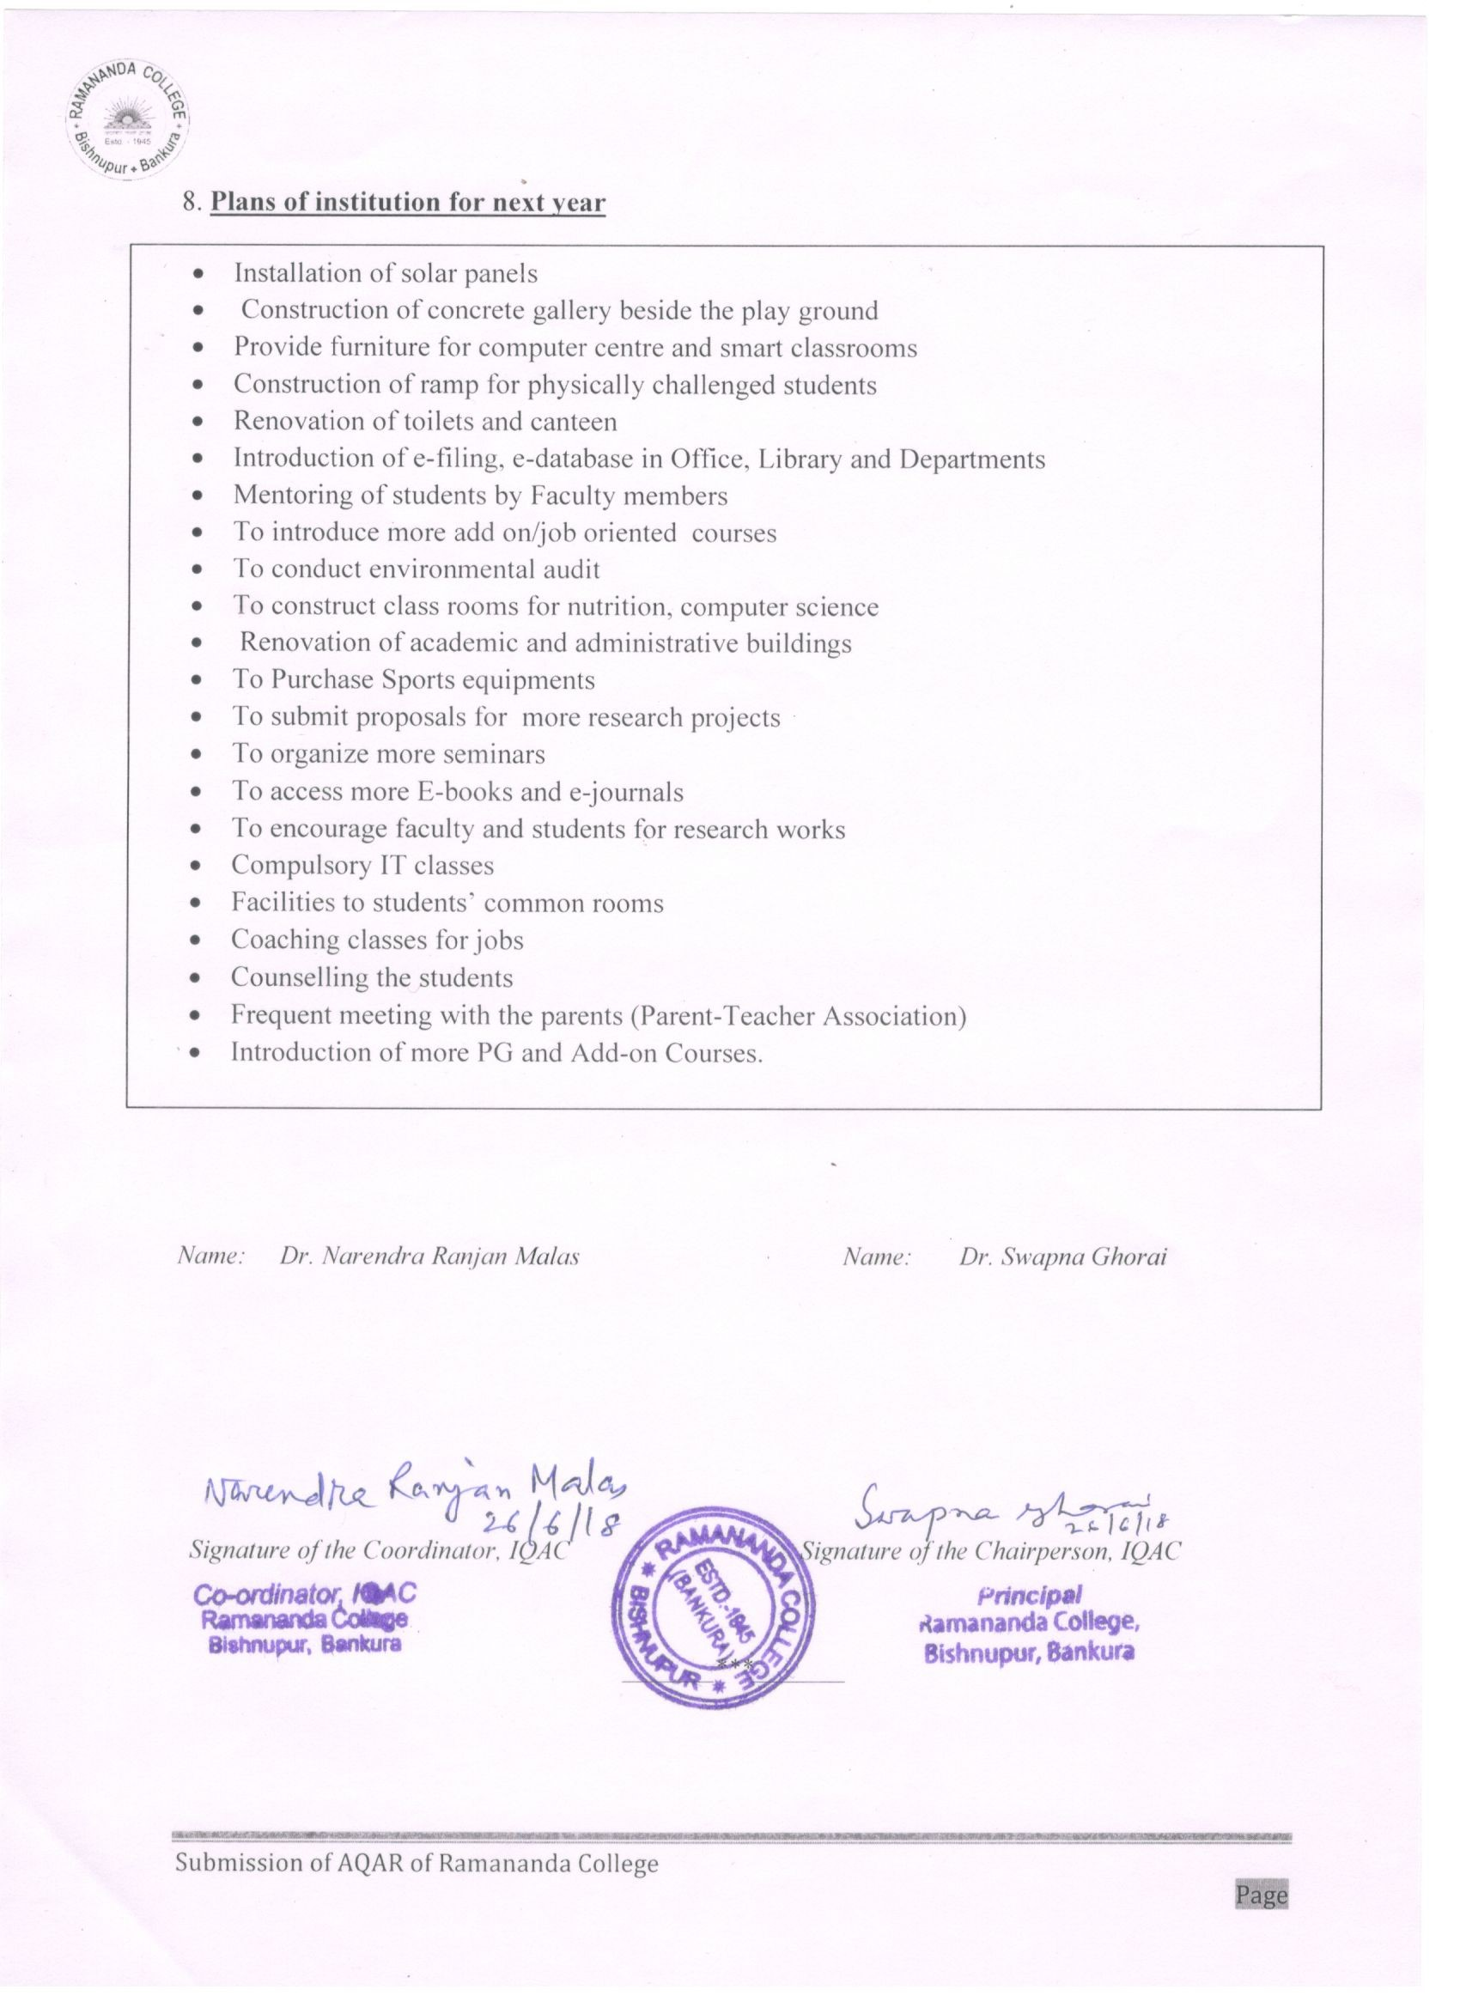

Annexure- I
Seminars/Workshops/Conferences
Sl. No. | Organized by | Title | Sponsored by | Held on
1 | Library & IQAC Ramananda College | Workshop on “N-List Orientation programme” | Ramananda College | 7th July, 2017
2 | Ramananda College | Seminar on “World Population Day” | Office of the District Magistrate, Bankura (Govt. of W.B.) | 11 th July,  2017
3 | Ramananda College | Seminar-I on  “150 th Birth Anniversary of Sister Nivedita” | Ramananda College | 4 th August, 2017
4 | Ramananda College | Seminar-II on  “150 th Birth Anniversary of Sister Nivedita & Cultural Competition” | Ramananda College | 24th September,2017
5 | NSS,  Ramananda College | Seminar on “Dengue & Chikungunya” | Govt. of W.B. | 7th September,2017
6 | Ramananda College & Tobacco Control Cell of Bankura, Govt. of W.B. | Seminar on “Tobacco Cessation Among the College Student – a Sensitization Campaign” | Tobacco Control Cell of Bankura, Govt. of W.B. | 14th November,2017
7 | Employment Exchange, Bishnupur, W.B. & Career Advancement Cell, Ramananda College | Seminar on “Career Talk Programme” | Govt. of W.B. | 28th November,2017
8 | Women Cell of Ramananda College | Seminar on “International Women’s Day” | Ramananda College | 8 th March,  2018
9 | IQAC, Ramananda college, Bishnupur | Institutional Level Workshop on “Promotoin Of Research Climate In The Institution.” | Ramananda College | 8th March, 2018.
10 | Mathematics & Botany Departments,  Ramananda College | National Seminar on “Recent Approaches of Mathematical Science in Advancement of Biotechnology” | DST, Govt. of W. B. | 28th March,  2018
11 | Women Cell & NSS of Ramananda College | Seminar on “Capacity Building and Gender Sensitization ” | Ramananda College | 6th April, 2018

Annexure - II

PROVISIONAL ACADEMIC CALENDER (2017-2018)

JULY-2017
- College Foundation Day : 1st July
- Admission to B.A/B.Sc/B.Com 1st SEM Classes: After 7 days of publication of H.S.results by WBCHSE.
- Commencement of B.A/B.Sc/B.Com 1st SEM & 2nd , 3rd Year Classes :
3rd Week of July
- Admission to B.A/B.Sc/B.Com 2nd & 3rd Year: After the publication of previous year’s results
Holidays : Nil

AUGUST-2017
- Regular Classes throughout the month
Holidays : 7th, 14th,15th
SEPTEMBER-2017
- Regular Classes throughout the month
- Freshers’ welcome by Students’ Union : 2nd Week of September
- Departmental Unit Tests : 3rd Week of September
Holidays : 2nd , 19th ,25-30th (Puja vacation)

OCTOBER-2017
- Regular Classes : After 21st October
Holidays : 1st -21st (Puja vacation)

NOVEMBER-2017
- Regular Classes throughout the month
- Seminars/Workshops to be organized :
- 2nd and 3rd Week of November by the Departments/College
- Internal Assessments: Last Week of November
Holidays : 4th

DECEMBER-2017
- Regular Classes ( 2nd and 3rd year) throughout the month
- Cultural Programmes/ Competitions/Prize Distribution Ceremony:
1st Week of December
- Examination of 1st SEM: 2nd & 3rd week of December
- Students’ Union Election: To be decided.
- Academic Excursion (Need Based): Last week of December

Local Holidays: 23rd -31st

JANUARY-2018
- Test Examination for 3rd yr. Hons. & General : 2nd &3rd week of January Regular Classes (For 2nd yr. and 1st yr.): Through the month
- Form Fill -Up (3rd Year): 4th Week of January
Holidays : 1st , 12th , 22th , 23th , 26th

FEBRUARY-2018
- Regular Classes throughout the month
- Annual Sports: 1st /2nd Week of February
- NCC/NSS Camp Programme: 3rd Week of February
- Test Exam. of 2nd year :1st & 2nd week of Feb.
Holidays :14th

MARCH-2018
- Special Classes of 2nd Year &regular classes of 2nd SEM
- Form Fill -Up of 2nd Year : 3rd /4th Week of March
Holidays :1st , 2nd , 30th
APRIL-2018
- University Final Exams (Part –III): 1st Week of April
- Special Classes of 2nd Year &regular classes of 2nd SEM: Throughout the month
- Internal Assessments: Last Week of April
Holidays : 14th , 30th
MAY-2018
- University Final Exams (Part -1 & II): 2nd Week of May onwards
- Form Fill-Up of 2nd SEM: Last week of May
Holidays : 1st , 9th , 21-31st ( study leave)

JUNE-2018
- University Final Examinations : Continuing throughout the month
- University Final Examinations (2nd SEM) : Last week of June
- Admission to B.A/B.Sc/B.Com 1st SEM: After the publication of H.S results by WBCHSE.
Holidays : 1-15th (Study leave), 16th
* Any change will be notified in advance. Students should follow the notice board and the college web site regularly.

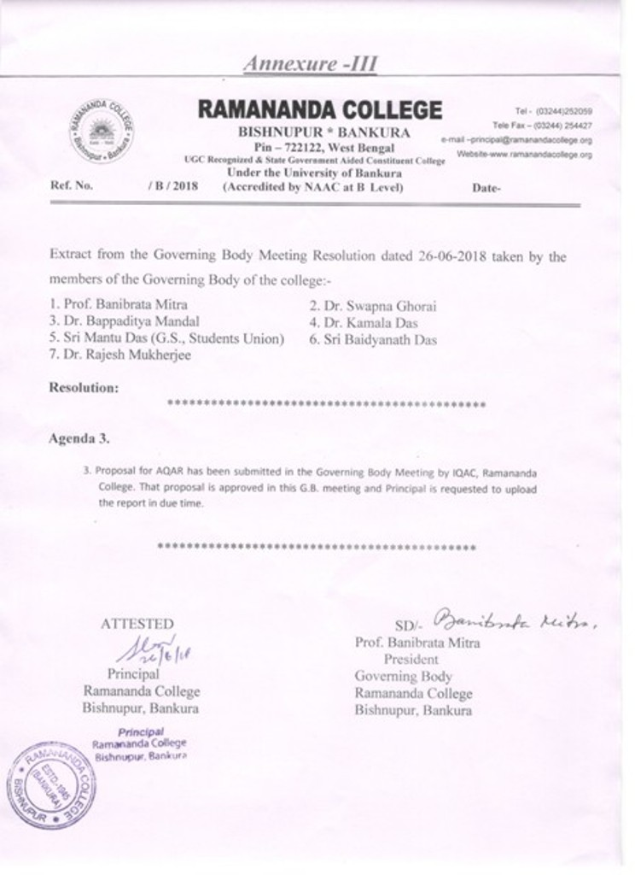

Annexure IV
List of Programmes (Session-2017-18) for Under Graduate/Post Graduate Course
Courses Offered by the College:
- PG – Programmes
  - Master in Arts (English)
  - Master in Arts (Bengali)
  - Master in Arts (Sanskrit)
  - Master in Science (Mathematics)
  - Master in Science (Botany)
2. UG – Programmes
  - Bachelor in Commerce (Accountancy- Hons)
  - Bachelor in Arts (Bengali – Hons)
  - Bachelor in Arts (English – Hons)
  - Bachelor in Arts (Sanskrit-Hons)
  - Bachelor in Arts (Geography – Hons)
  - Bachelor in Arts (Political Science – Hons)
  - Bachelor in Arts (History – Hons)
  - Bachelor in Arts (Economics – Hons)
  - Bachelor in Arts (Philosophy– Hons)
  - Bachelor in Arts (Education-Hons)
  - Bachelor in Science (Mathematics – Hons)
  - Bachelor in Science (Physics – Hons)
  - Bachelor in Science (Chemistry – Hons)
  - Bachelor in Science (Zoology-Hons)
  - Bachelor in Science (Botany-Hons)
  - Bachelor in Science (Physiology – Hons)
  - Bachelor in Science (Nutrition – Hons)
  - Bachelor in Arts (Physical Education- General)
  - Bachelor in Pure Science (General)
  - Bachelor in Bio- Science (General)
  - Bachelor in Arts (General)
  - Bachelor in Commerce (General)

Annexure - V
Analysis of students’ feedback
A questionnaire has been designed covering all the segments of the college into five broad categories like, Administrative & office, Teaching and learning, Library, Extra-curricular activities and overall matters to collect the Students’ feedback on the above mentioned fields of their respective Departments as well as College. This was supplied to individual outgoing third year (Honours) students to have their views as well as experience gathered by them during the period of their study in this Institution. The students of different departments have given their response to the questionnaire supplied to them.
A criterion is set to evaluate their response. Score below 60% is taken as lower boundary for which proper actions are to be taken and score above 80% is considered as satisfactory level. In between 60% to 80% is treated as desirable level.
In the area of Extra-Curricular Activities, the average score is 52.5% i.e below 60% which indicates the overall poor involvement of the Students in this field. Much more attention is to be given in this field by encouraging the students to participate in different programmes organised/ arranged by College and University.
In case of College Administration and Office, the average score is 66.7% which is at desirable level. To have better results, initiative is to be taken to provide the sufficient basic requirements like, facilities for drinking water, cheap canteen, Hostel arrangements at lower cost and hassle free official support as per their needs.
In the field of teaching learning system, the average score is 79.2% which is very close to the norm of satisfactory level. It may be improved by employing constant monitoring on Students attendance. Increase in student attendance will be helpful to cover syllabus to a great extent, to take remedial measures and to develop teacher-student relationship.
Students’ assessment regarding library is satisfactory. Average score at this criterion is 95%. More student friendly environment in library is to be maintained at each and every point of time.
Students’ attitude on overall matters of the College is satisfactory.

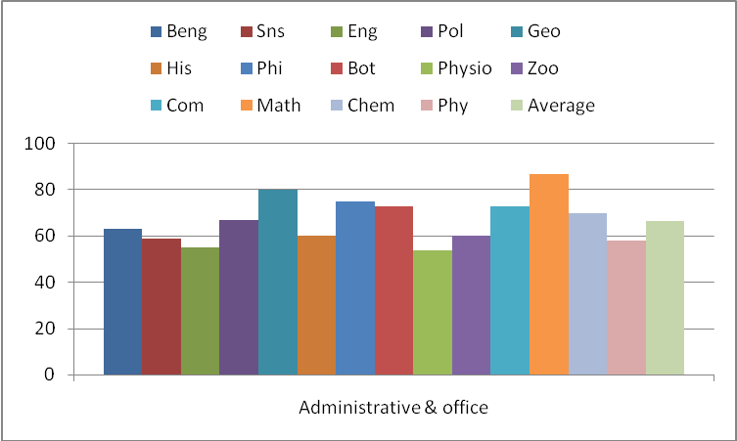

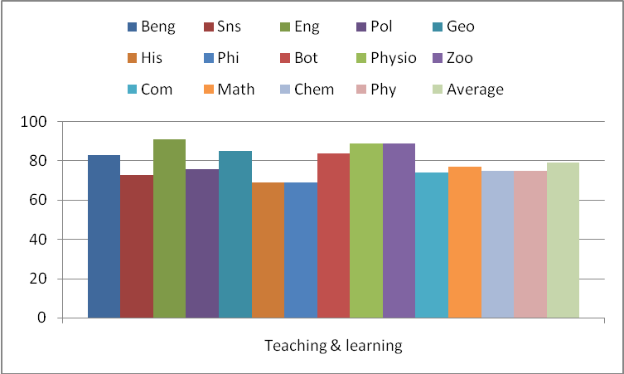

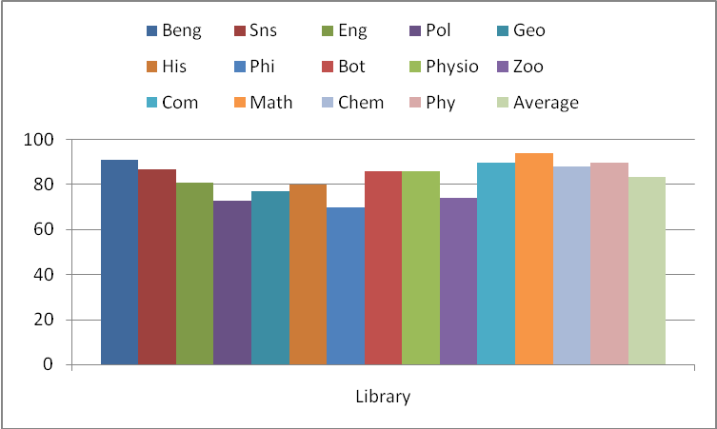

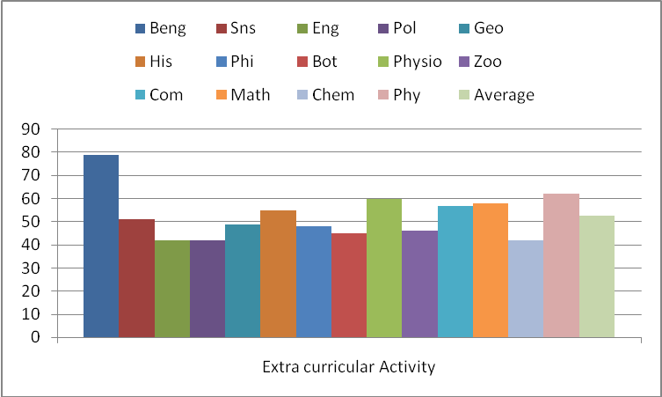

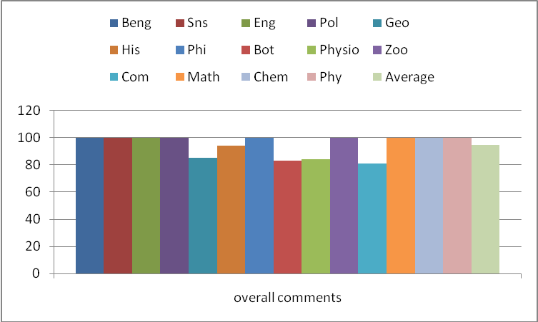

Annexure – VI

SCHOLASHIPS, STIPENDS and STUDENTS’ CONCESSION
Some of our students avail of scholarships from both Government and private bursaries.
Funding Agencies:
- Merit cum Means Scholarship (WB) -205
- Chief Minister’s Relief Fund-60
- Physically Handicapped Scholarship-02
- Kanyashree Prakalpa K1 & K2 (WB Government)-404
Kanyashree Prakalpa K3 only for PG students (WB Government)-13
- INSPIRE PROGRAMME,Dept. Science & Technology, Govt. of India. -04
(Only for Science Students)
- LIC Scholarship for LIC employees -Nil
- Post Matric Scholarship (State Govt.):
a) SC--436
b) ST—103
c) OBC—627
- DEFENCE Scholarship (Govt of India).-Nil
- Child Army(BSF)-Nil
- Financial assistance/scholarships (Beedi Worker Welfare Fund)-02
- Ramakrishna Mission-02
- Priyangbada Birla Scholarship-01
- Sheela Kanoria Foundation-Nil
- Dr. Dulal Chandra Ghosh Scholarship-Nil
- AUQ of Board (Only for Muslim Students)-01
- Minority Scholarship ( West Bengal Govt.) -42
- Sitaram Jhindal Foundation-10
- Paramparik Foundation-02
- Fair and Lovely-Nil
- Rastriya Sanskrit Samity-01
- National Scholarship -169
- Samajik Surakha jojhona(W.B)-03
- P.G. Indira Gandhi Scholarship for single girl child-01
- Ashrukona Roy Memorial Scholarship-06

* 10% of admitted students to get full concession on tuition fees according to their need as per Government rules.

